This document should be used to record any incidents where the physical restraint of a child has been deemed necessary. The form must be
completed as soon after the incident as possible and the original must be given to the designated safeguarding lead person (Miss W Richmond) or the deputy designated safeguarding person (Miss S Baker). Please continue on separate record sheets if necessary, all sheets must be clearly numbered, signed and dated by the person completing the form.

Name of person completing the form:

Date of incident:_ __________________ Time of incident: ____________________________

Location of incident:_________________________________

Name of child: _____________________________________ Have parents been informed? Yes / No

Does the child have a safety and support plan? Yes/No

Name of person/s NCSI trained:____________________________________________

Date of blue badge issue: _________________________________________________

Names of any additional adults: ____________________________________________

Please complete a detailed record of the incident including, reasons behind the restraint, location, description of the incident on your arrival, what holding techniques were employed, length of each hold and how the incident was resolved. Use the Crisis Development Model for your reporting.

Crisis Development/Behaviour Levels |  | Staff Attitudes/Approaches
What anxiety signs did the child display before the intervention? |  | What supportive actions did the adult use?
What defensive signs did the child display before the intervention? |  | What directive actions did the adult use?
What risky behaviours was the child displaying? |  | What Safety Interventions were used and for how long for each?
What signs of tension reduction did the child display? |  | What therapeutic rapport techniques were used?
Decision Making Matrix:  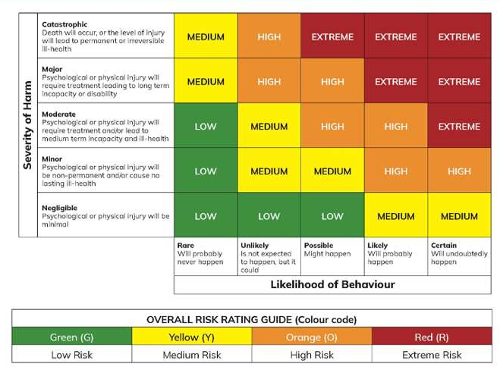 |  |  | Describe your rationale for intervention based on severity and likelihood.

A low-level hold in a seated position for a young person (chair) is when staff stay seated to the side of the child, they stay balanced and non-threatening and move closer to the child and place one hand on top of the child’s hands. A low- level hold in a seated position for a child (chair) is when one member of staff remain seated behind the child, they remain close and place their hands on the outside of the arm.
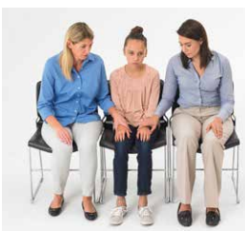 | 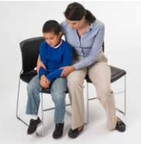
A medium-level hold in a seated position (chair) is when staff begin in a low-level hold (as pictured above). One member of staff moves their free hand to the outside of the elbow, they then loop their hand that was rested onto the child’s hand through their arm and move closer to the child. The second of member of staff repeats this action to secure the hold and minimise risk. A medium-level hold in a seated position for a child (chair) is when a member of staff begins in the low-level hold (as pictured above). The member of staff moves one hand at a time on top of the child’s forearm. They cup their hands to ensure no harm. The child’s arms rest against their own body. Staff move slightly closer maintaining a medium level of restriction.
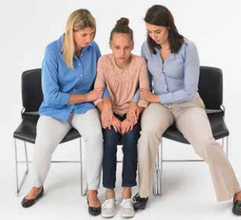 | 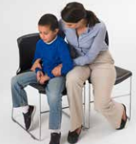

A high-level* hold in a seated position (chair) is when staff begin in a medium-level hold (as pictured above). Both members of staff use their hand that is looped under the child’s arm to guide the wrist underneath the shoulder and their elbow will naturally move backwards. Staff keep close to the child in distress. A high-level hold in a seated position for a child (chair) is when a member of staff begins in the medium-level hold (as pictured above). Staff guide the child’s arms forwards and cross them in front of their body, staff then place their hands around the child’s wrist and tuck them into the child’s body so the wrists rest underneath the shoulder. Staff lean back slightly and keep the child close to maintain a high-level hold.
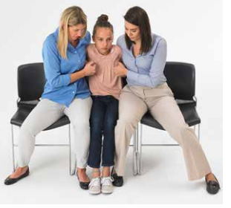 | 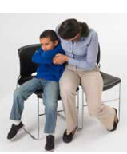

When using a low, medium and high-level standing hold for children, staff use the same principles as the seated holds. Please see the pictures below.
Low-level Medium-level High-level*
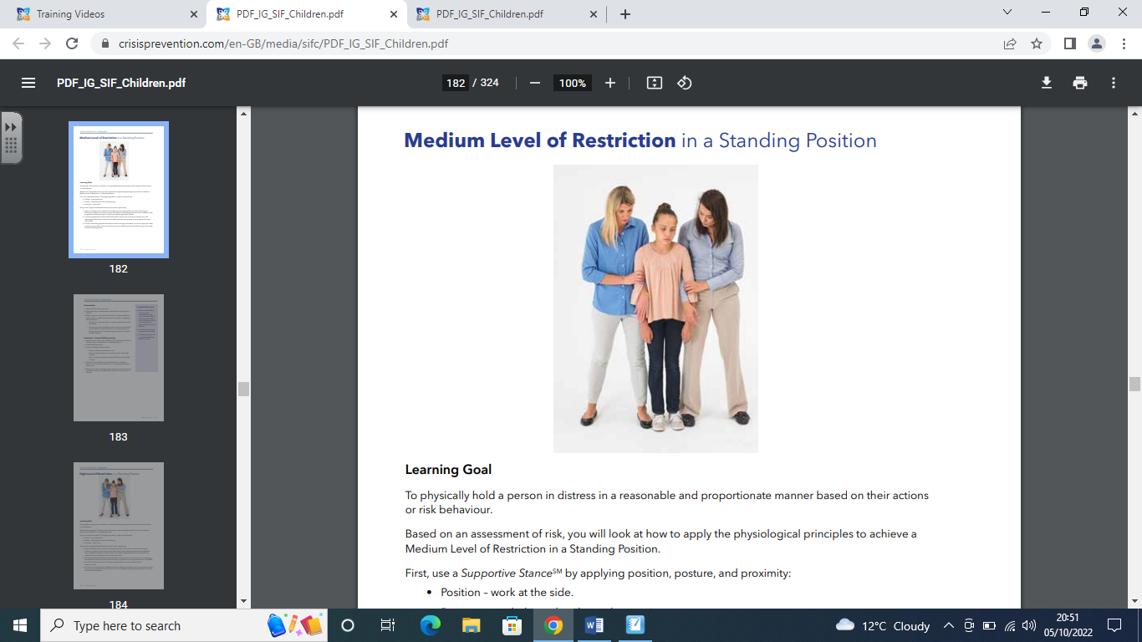
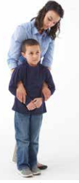
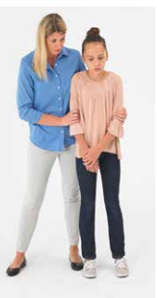
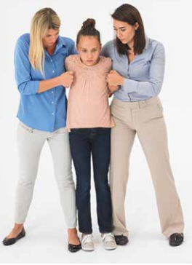
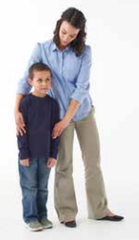
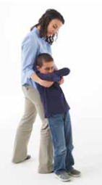

*Please note that whilst a high-level hold is part of the CPI Safety Intervention model for children and young people it would only be used in a serious incident.

Please indicate on the body map where the child was held.
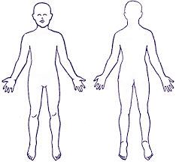

For Office Use Only:

Name of child:___________________________ Date of Birth:__________________

Gender:_________________ Ethnicity:_____________________

Name of designated person informed:_____________________________________

Date:__________________________ Signature of DSP:______________________

Have all parties completed individual accounts? Yes / No

Have all accounts been collected and stored together? Yes /No

Is a safety and support plan required for the child? Yes/No

Have parents been informed? Yes / No

Number of previous incidents recorded for the child: _________

Outcome:

